The Entity-Relationship Diagram (ERD)
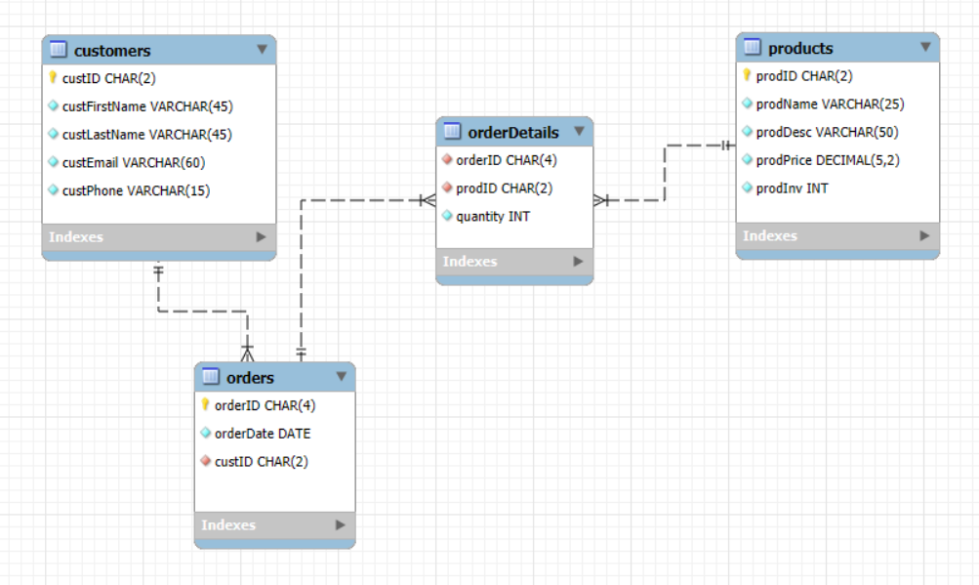
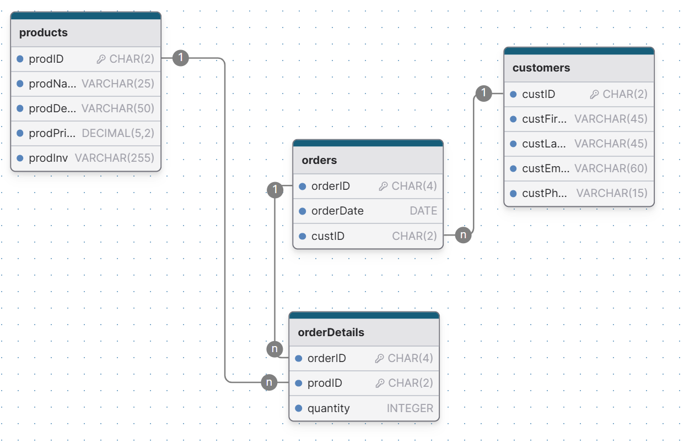

Products Table Code with Show Columns (Proof of Table Creation)
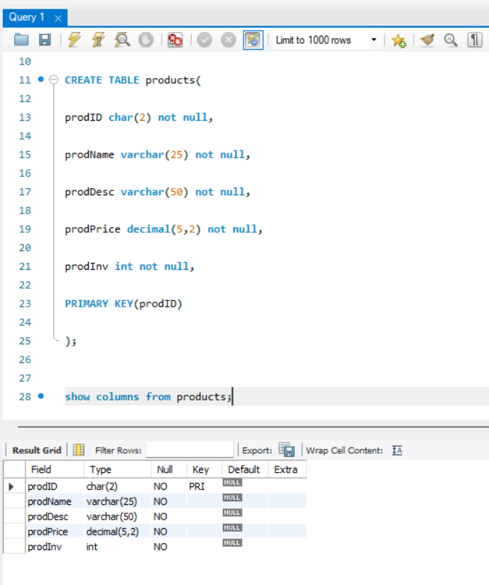

Insert Statement for Products Table
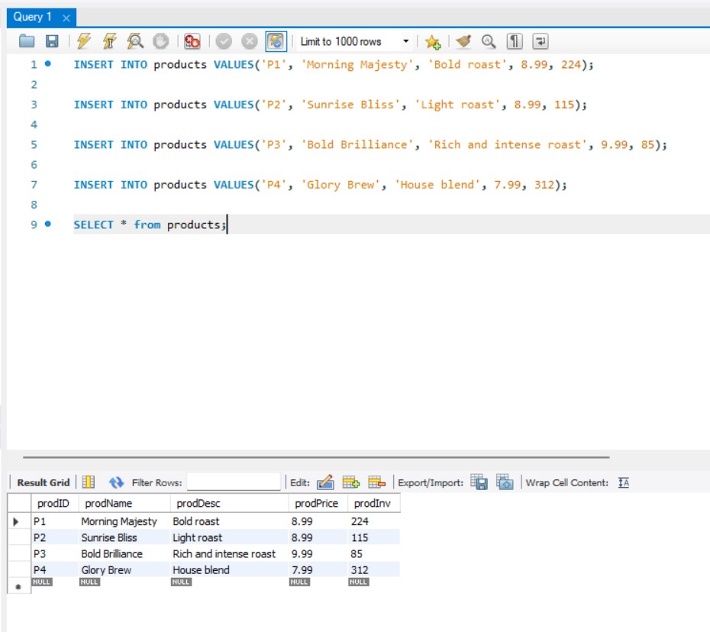
Customers Table Code with Show Columns (Proof of Table Creation)
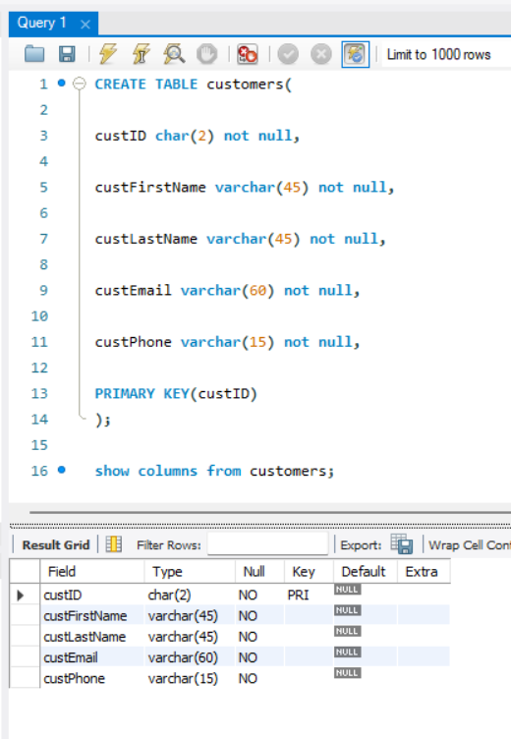

Insert Statement for Customers Table
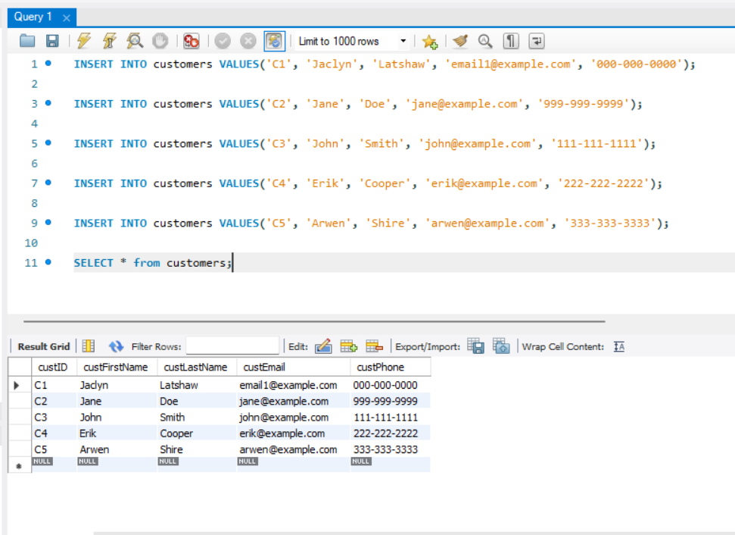

Orders Table Code with Show Columns (Proof of Table Creation)
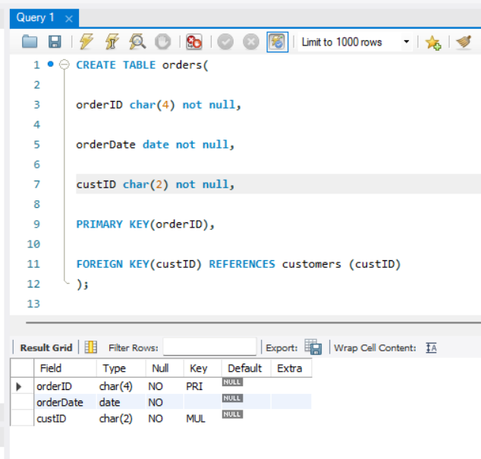

Insert Statement for Orders Table
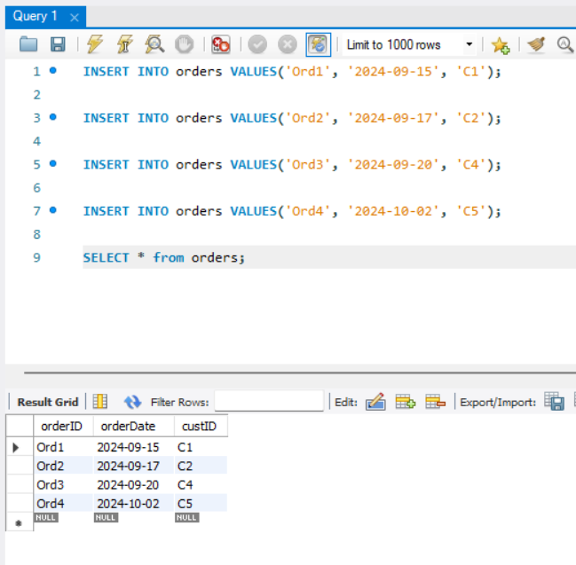

OrderDetails Table Code with Show Columns (Proof of Table Creation)
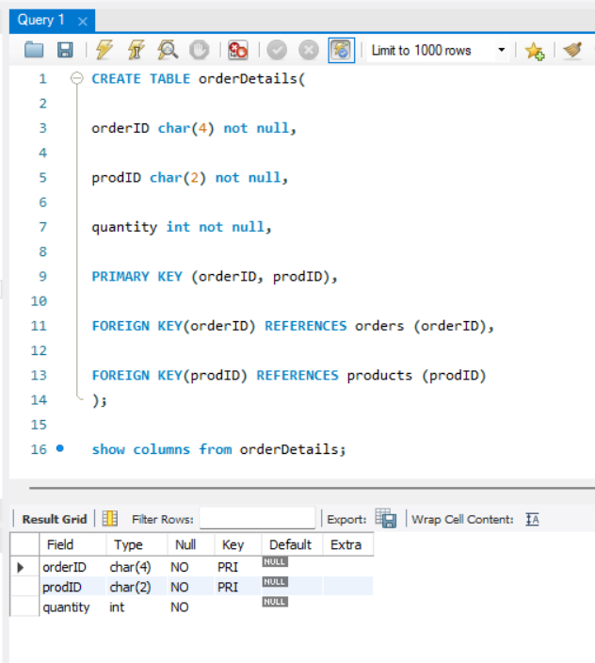

Insert Statement for OrderDetails Table
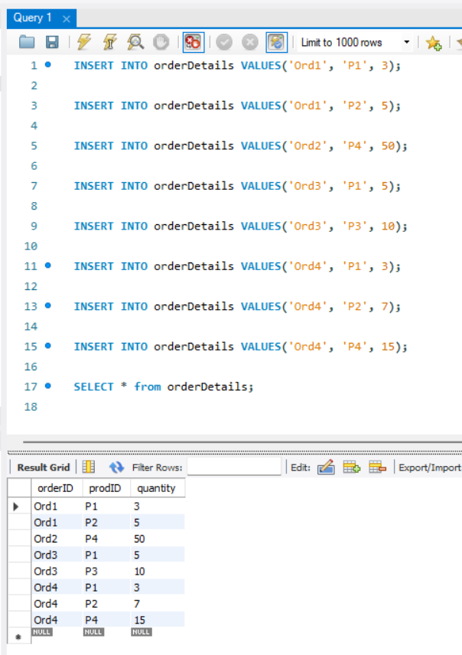

Proof of Table Creation in the Tab Area
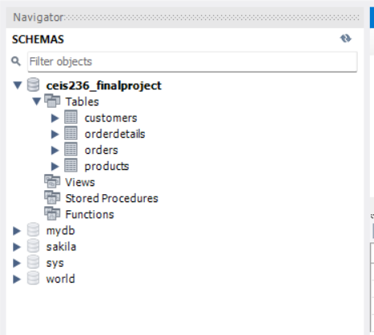

Queries Section:
1. Write a query to list all products that cost less than 9.
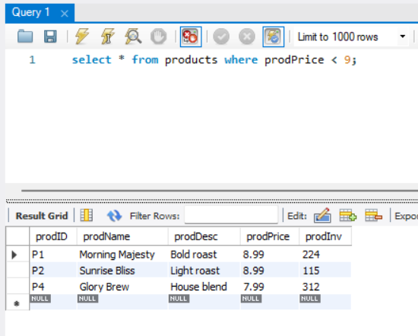

2. Write a query to display average, minimum, and maximum product inventory.
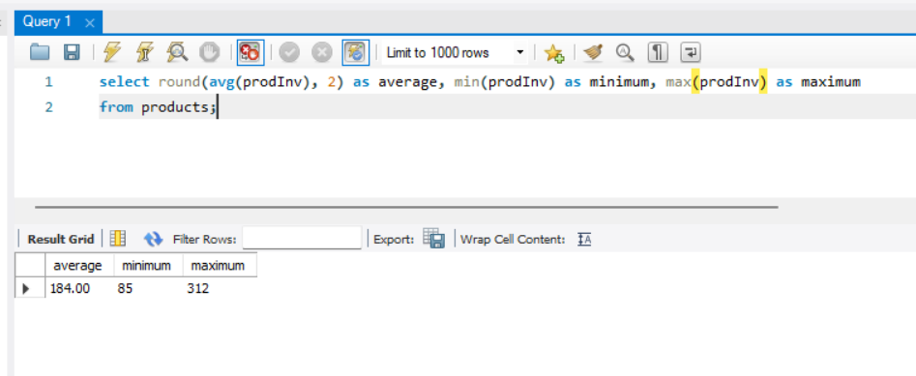

3. Write a query to count the number of orders before October 1, 2024.
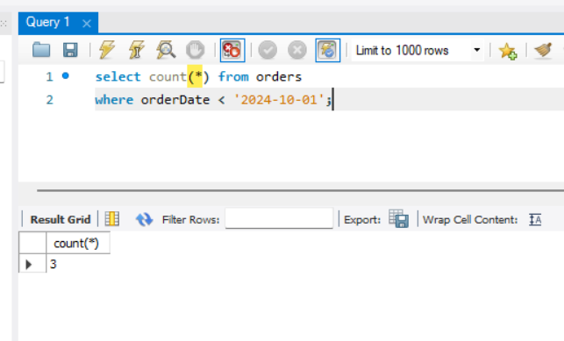

4.Write a query to display the last name of all customers who ordered product P1.
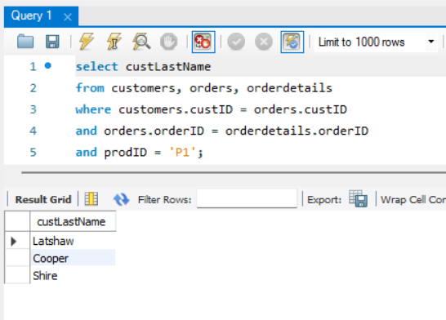

5. Write a query to display the names of all customers who have no orders.
